**CAPTIOUS NIDUS**

Submitted in partial fulfillment of the requirements

of the degree of

Bachelor of Engineering

in

Information Technology

by

Kavya Menda 213A3069

Niketa Rampally 111A3040

Shreya Vhadadi 112A3063

Under the Guidance of:

Prof Bushra Shaikh



Department of Information Technology

SIES graduate School of Technology

2015-2016

**CERTIFICATE**

This is to certify that the project entitled **“Captious Nidus”** is a bonafide work of the following students, submitted to the University of Mumbai in partial fulfillment of the requirement for the award of the degree of **Bachelor of Engineering** in **Information Technology.**

**Niketa Rampally 111A3040**

**Shreya Vhadadi 112A3063**

**Kavya Menda 213A3069**

Prof Bushra Shaikh Prof Leena Ladge DrAlkaMahajan

Internal Guide Head of Department Principal

**PROJECT REPORT APPROVAL**

This project report entitled (***Captious Nidus***) by following students is approved for the degree of ***Bachelor of Engineering*** in ***Information Technology***

***Niketa Rampally 111A3040***

***Shreya Vhadadi 112A3063***

***Kavya Menda 213A3069***

**Name of External Examiner: --------------------------------**

**Signature:--------------------------------**

**Name of Internal Examiner: --------------------------------**

**Signature:--------------------------------**

**Date:**

**Place:**

**DECLARATION**

I declare that this written submission represents my ideas in my own words and where others’ ideas or words have been included, I have adequately cited and referenced the original sources. I also declare that I have adhered to all principles of academic honesty and integrity and have not misrepresented or fabricated or falsified any idea/data/fact/source in my submission. I understand that any violation of the above will be cause for disciplinary action by the Institute and can also evoke penal action from the sources which have thus not been properly cited or from whom proper permission has not been taken when needed.

Niketa Rampally (111A3040) _____________

Shreya Vhadadi (112A3063) _____________

Kavya Menda (213A3069) _____________

Signature

Date:

**ACKNOWLEDGEMENT**

It gives us immense pleasure to thank Dr. Alka Mahajan, our Principal for extending her support to carry out this project. We wish to express our deep sense of gratitude and thank to our Internal Guide, Prof Bushra Shaikh for his/her guidance, help and useful suggestions, which helped in completing our project work in time.

Also we would like to thank the entire faculty of Information Technlogy department for their valuable ideas and timely assistance in this project, last but not the least, we would like to thank our teaching and non teaching staff members of our college for their support, in facilitating timely completion of this project.

**Project Team**

Niketa Rampally

Kavya Menda

Shreya Vhadadi

**ABSTRACT**

Earlier it was the Internet of computers, later it became internet of mobile, now the trend is internet of things or internet of everything where unconnected and uniform devices of our daily lifestyle communicate using internet. Our Project is about Home automation based on IoT(Internet of things) which includes everything that you can imagine to control and automate your home. Smart home is a very promising area, which has various benefits such as providing increased comfort, greater safety and security, a more rational use of energy and other resources thus contributing to a significant savings

Project is implemented using arduinouno with the help of Ethernet shield. The Ethernet shield acts as a medium to connect to the internet , inturn reducing the overall cost of the project. The four channel relay device is used as an interface between the Arduino and Electrical Appliances. Most importantly the project focuses on controlling and monitoring the home environment via a website which can be accessed by any remote PC from any place at anytime,thus eliminating the need of Single dedicated PC.

Keywords :-IoT, Internet, Arduino Uno, Ethernet shield, Relay, Smart home

**Contents**

|  |  |  |
| --- | --- | --- |
|  |  | **Page No.** |
| **Chapter 1** | **Introduction** |  |
| **Chapter 2** | **Review of Literature** |  |
| **Chapter 3** | **Report on Present Investigation** |  |
|  | **3.1 Problem Statement** |  |
|  | **3.2 Concept** |  |
|  | 3.2.1 Arduino Uno |  |
|  | 3.2.2 Wiznet 5100 Ethernet sheild |  |
|  | 3.2.3 Four Channel Relay |  |
|  | 3.2.4 Arduino IDE |  |
|  | **3.3Proposed System** |  |
|  | **3.4Design of the System** |  |
|  | 3.4.1 Data flow Diagram |  |
|  | 3.4.2 Use Case Diagram |  |
|  | 3.43 Class Diagram |  |
|  | **3.5 Block Diagram** |  |
|  | **3.6 Working** |  |
|  | **3.7 Feasibility** |  |
|  | 3.7.1 Technical |  |
|  | 3.7.2 Financial |  |
|  | 3.7.3 Operational |  |
|  | **3.8 Software and Hardware requirements** |  |
| **Chapter 4** | **Results and Discussions** |  |
| **Chapter 5** | **Conclusions** |  |
| **Appendix** |  |  |
| **References** |  |  |
| **Publications** |  |  |

**List of Figures**

|  |  |  |
| --- | --- | --- |
| **Figure**  **No.** | **Figure Caption** | **Page**  **No.** |
| 3.1 | Internet of Things |  |
| 3.2 | Arduino Uno |  |
| 3.3 | Ethernet Shield |  |
| 3.4 | Four Channel relay Device |  |
| 3.5 | Design |  |
| 3.6 | Data flow Diagram |  |
| 3.7 | Use Case Diagram |  |
| 3.8 | Class Diagram |  |
| 3.9 | Block Diagram |  |
| 4.1 | Login Page |  |
| 4.2 | User page |  |

**CHAPTER 1**

**Introduction**

Home automation or smart homes (also known as domotic) can be described as introduction of technology within the home environment to provide convenience, comfort, security and energy efficiency to its occupants. The Internet of Things (IoTs) can be described as connecting everyday objects like smart-phones, Internet TVs, sensors and actuators to the Internet where the devices are intelligently linked together enabling new forms of communication between things and people, and between things themselves. With the introduction of the Internet of Things, the research and implementation of home automation are getting more popular. IoTs technology are been applied to create a new concept and wide development space for smart homes to provide intelligence, comfort and to improve the quality of life. Various wireless technologies that can support some form of remote data transfer, sensing and control such as Bluetooth, Wi-Fi, RFID, and cellular networks have been utilized to embed various levels of intelligence in the home.

Arduino is a platform that you can use to quickly prototype electronic systems. It is actually the perfect platform to build home automation systems. A Ethernet Shield based automation system is also implemented along with Arduino for remotely controlling the appliances. The System works as a remote controller for the electrical appliances at home to check whether it is ON or OFF. We are integrating some of these systems in an Internet of things perspective by sending some data directly to the cloud server.

Although this system procedure overcomes the shortcomings of communications techniques, this method provides a parallel implementation of hardware that results using fast algorithm execution. The proposed Arduino Uno controller provides a simple implementation to the system as compared to the other types of controllers. This system has two operational modes; the first one of them is based on a cellular phone while the second one is considered using a website. To support our claim, a hardware implementation for the proposed system is developed to verify its reliability and limitations. In order to address the mentioned issues of flexibility and functionality we have designed and implemented a novel, standalone, flexible and low cost home controlling and monitoring system.

**CHAPTER 2**

**Review of Literature**

When it comes to controlling of home humans have no option then to themselves go to the switching socket to switch ON or OFF the appliances as and when required .Also it’s a human tendency to forget switching off the light and fan often when they leave their house in a hurry. Today no system prevails to address these issues smartly. Keeping this in mind our project utilizes web service in the most open and interoperable way to provide remote access of home devices to the users. In addition our project offers a powerful means for helping and supporting special needs of the elderly and people with disabilities by monitoring home environment through a single click on the control button of web page designed for it. This webpage created is controlled by the web browser of any local PC in the same LAN.

Mr.AbhishekVichare and Ms.ShilpaVerma proposed a new approach to control home appliances from a remote terminal with an option from a local server using the internet.The vision of the system is to provide an efficient internet based systems to control everyday system to control everyday home appliances. The system offers users an easy and effective means of controlling these various home appliances from a remote location i.e without physically being present at home. The system makes use of the internet to enable remote access to the various home appliances. Apart from merely turning the appliances on and off the scope of the system can be extended to regular their output power and set their usage time [1].

Rajeev Piyare proposes architecture to enable the users to control and monitor smart devices through internet. It creates an interface between users and smart home by using GSM and internet technologies, or it simply creates GSM based wireless communication from the web server into smart home. In this architecture the users give commands through web then the users inputs are converted into gsm-sms commands. Every day the modern people expect new device and new technology to simplify their day to day life. The innovators and researchers are always trying to find new things to satisfy the people but the process is still infinite. Global System for mobile communication is a vital communication technology and the proposed architecture uses gsm and primary communication technology between the home and IOT agent [2].

The vision of the system by S.Pandikumar and R.S. Vetrivel is to provide an efficient internet based system to control everyday home appliances. The system offers users an easy and effective means of controlling their various home appliances from a remote location ie without physically being present at home. The system makes use of internet to enable remote access to the various home appliances [3].

The proposed system by AbdulrahmanYusuf and MurtalaAminu Baba, has two operational modes. The first one is denoted as a manually–automated mode in which the user can monitor and control the home appliances from anywhere over the world using the cellular phone through Wi-Fi communication technology. The second one is referred to a self- automated mode that makes the controllers to be capable of monitoring and controlling different appliances in the home automatically in response to the signals comes from the related sensors. This system is scalable and permitted any number of different appliances to be added with no major changes in its core.. It communicates with the Arduino Uno microcontroller board through USB data transfer cable. Although this system procedure overcome the shortcomings of communications techniques, but still need some improvement. A system that uses GSM- Bluetooth based controller and remote monitoring is proposed in [4].

To show the effectiveness and feasibility of this proposed system, a remote control, indoor control and outdoor control systems have been developed and evaluated. However, integrating the system with android application remains unsuccessful. Due to the proliferation of modern technology, these days, the world is increasingly experienced the use of wireless devices. The devices such as remote control and GSM phone could provide means for monitoring and controlling home appliances in a more convenient way. This project has explored the concept of home automation and ZigBee technology. A home automated system based on Arduino and ZigBee are developed which is tried to be integrated with Android application through Home Gateway for network interoperability [5].

**CHAPTER 3**

**Report on Present Investigation**

**3.1 Problem Statement**

Home automation systems face four main challenges these are high cost of ownership, inflexibility, poor manageability, and difficulty in achieving security. The main objectives of this project is to design and implement a home automation system using IoT that is capable of controlling and automating most of the house appliances through an easy manageable web interface. The proposed system has a great flexibility by using Ethernet shield to interconnect its distributed appliances to home automation server. This will decrease the deployment cost and will increase the ability of upgrading and system reconfiguration.

**3.2 Concept**

Internet of things (IoT) for short, is a simple concept that covers an increasingly complex application : everything is connected to the internet. Whether it is a the appliances in your house or robotic manufacturing device , a soda machine at the mall, the guidance system or the google glasses on your face, Virtually everything will be talking to each other except perhaps the actual humans and its all happening right now, all around us.

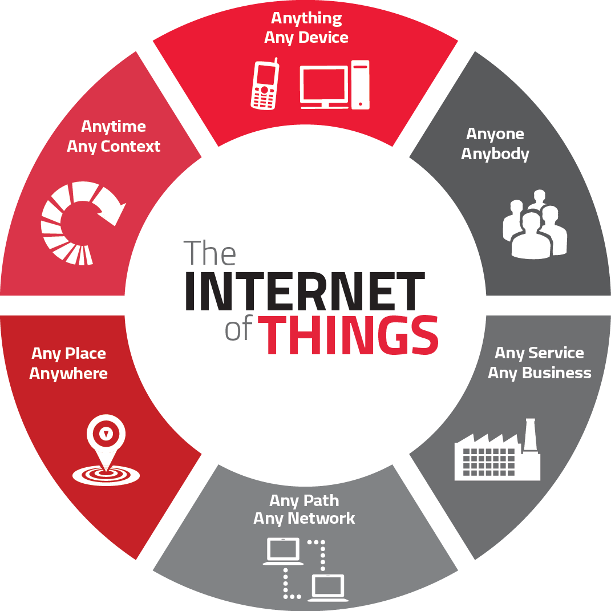

Figure 3.1 Internet of things

**3.2.1Arduino Uno:**

Arduino is an open-source computer hardware and software company, project and user community that designs and manufactures microcontroller-based kits for building digital devices and interactive objects that can sense and control the physical world. These systems provide sets of digital and analog I/O pins that can be interfaced to various expansion boards ("shields") and other circuits. The boards feature serial communications interfaces, including USB on some models, for loading programs from personal computers. For programming the microcontrollers, the Arduino platform provides an integrated development environment (IDE) based on the Processing project, which includes support for C, C++ and Java programming languages.

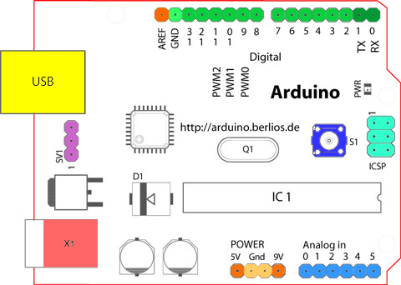

Figure 3.2 Arduino UNO

**3.3.2Wiznet Ethernet W5100 Shield:**

The Wiznet Ethernet W5100 Shield allows an Arduino board to connect to the internet. It is based on the Wiznet W5100 Ethernet chip providing a network (IP) stack capable of both TCP and UDP. The Ethernet Shield supports up to four simultaneous socket connections. Use the Ethernet library to write sketches which connect to the internet using the shield.

The on-board micro-SD card slot can be used to store files for serving over the network. It is compatible with the Arduino Uno and Mega (using the Ethernet library). You can access the on-board SD card slot using the SD library which is included in the current Arduino build.

Arduino communicates with both the W5100 and SD card using the SPI bus (through the ICSP header). This is on digital pins 11, 12, and 13 on the Uno and pins 50, 51, and 52 on the Mega. On both boards, pin 10 is used to select the W5100 and pin 4 for the SD card. These pins cannot be used for general i/o. On the Mega, the hardware SS pin, 53, is not used to select either the W5100 or the SD card, but it must be kept as an output or the SPI interface won't work.

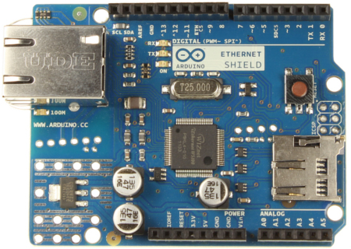

Figure 3.3 Ethernet shield

**3.2.3 Relay**

This is a 5V 4-Channels Relay module, It can be controlled directly by a wide range of microcontrollers such as Arduino, AVR, PIC, ARM and MSP430.4 relays are included in this module, with “NC” ports means “Normally connected to COM” and “NO” ports means “Normally open to COM”. This module also equipped with 4 LEDS to show the status of relays.

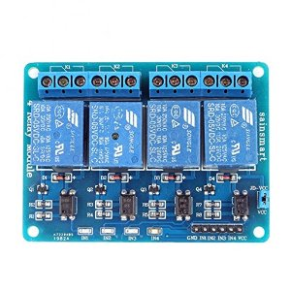

Figure 3.4 Four channel relay device

**3.2.4 Arduino IDE**

The Arduino integrated development environment (IDE) is a cross-platform application written in Java, and derives from the IDE for the Processing programming language and the Wiring projects. Arduino integrated development environment (IDE) makes it easy to write code and upload it to the board. It is designed to introduce programming to artists and other newcomers unfamiliar with software development. It includes a code editor with features such as syntax highlighting, brace matching, and automatic indentation, and is also capable of compiling and uploading programs to the board with a single click. A program or code written for Arduino is called a "sketch".

**3.3 Proposed System**

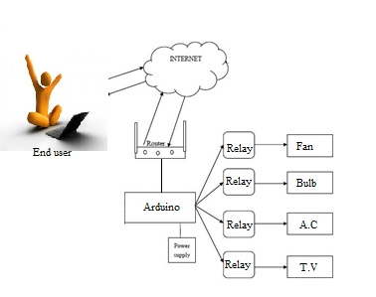

Figure 3.5 Design

We proposed Arduino controlled relay board system based on Internet of Things technology for transmission of instruction from controller to devices. Instruction sending and receiving is used for universal access of appliances at home with just an IP Address. These project includes 4 relay outputs and 4 inputs. Connection to the isolated inputs and relay outputs is via female to male jumper wires. This control system is based on Arduino connected to network technology via Ethernet sheild for transmission of instruction from sender to receiver. Request sending and receiving is used for ubiquitous access of appliances and allowing breach control at home. The user can monitor the electrical appliance via a web server and hence will be able to view if any device is left ON unintensionally.

**3.4Design of the system**

**3.4.1 Data flow diagram**

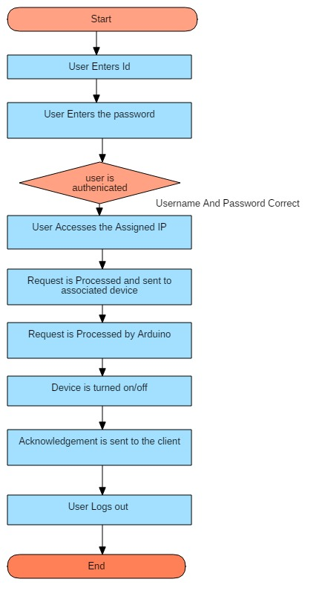

Figure 3.6 Data Flow Diagram

**3.4.2 Use Case Diagram**

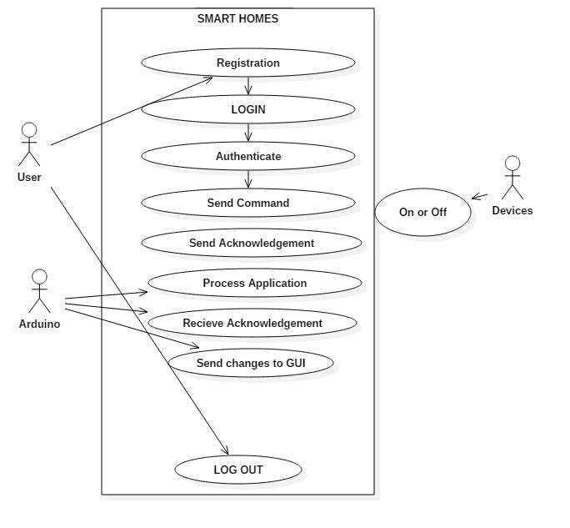

Figure 3.7 Use Case Diagram

**3.4.3 Class Diagram**

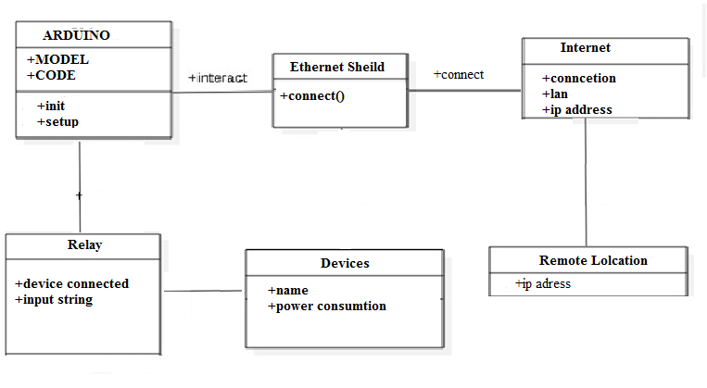

Figure 3.8Class Diagram

**3.5Block Diagram**

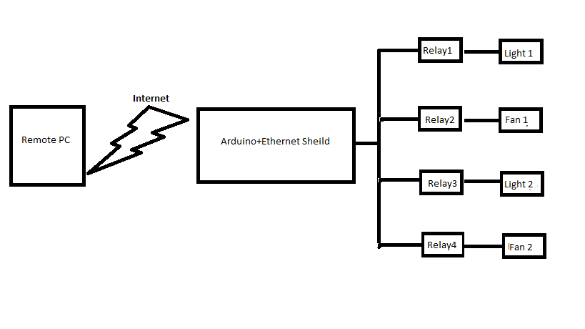

Figure no 3.9 Block diagram

**3.6 Working**

The proposed home automation system consist of Arduino Uno, Ethernet sheild(overlapped over the Arduino and connected to the laptop via Ethernet cable) and a four channel relay device. Initially Arduino connects to the internet through the Ethernet shield and once the connection is established the script/code uploaded on the Arduino board gets executed. The internet connection is supported by a web browser of a local desktop pc in the same LAN. The user needs to enter the server IP within the same LAN connection such that any remote pc or handheld device using internet can have an access to the web page created .In addition to this the fig1 also shows the relay connection wherein each different pins of a four channel relay are connected to the separate electrical appliance. The user can monitor the electrical appliance through the internet via a web server. So if the light/fans or any electrical appliances are left ON in hurry can be seen and turned OFF remotely through simply typing the IP address of the web page and clicking the OFF button of the required appliance.

**3.7 Feasibility Study**

**3.7.1 Technical**

Technical analysis begins with an assessment of the technical viability of the proposed system. In this study we made an analysis on what technologies can be used to accomplish system function and performance. We have come to a conclusion that Arduino has faster processing capability as compared to raspberry pie and also it is far more reliable as compared to many other home automation systems.

**3.7.2 Financial**

The financial investment is feasible for creating this application. As Arduino is available at a cheaper price and Arduino IDE software is free of cost. Also other hardware equipments such as Ethernet shield is cheap making the overall project cost effective.

**3.7.3 Operational**

The project being developed is very useful as the information is been access by the user and processing is based on the user’s preferences and system functionality, hence it saves user’s time.

**3.8 Software And Hardware Requirements**

Software Requirements

* Arduino ide
* CSS
* AJAX
* Html
* Internet Explorer

Hardware Requirements

* Ethernet Shield
* Ethernet cable
* Relay
* Ardiuno uno (atmega 36)
* SD Card

**CHAPTER 4**

**Results and Discussions**

After the successful connection to the server, the data is sent to the web server for monitoring of the system. The figure shows the web server page which will allow us to monitor and control the system. By entering the assigned IP address in the web browser this web server page will appear. The web server gives the information of the motion state in the house. Basically it gives the status of the various electrical appliances like light, fan etc which we can control remotely.

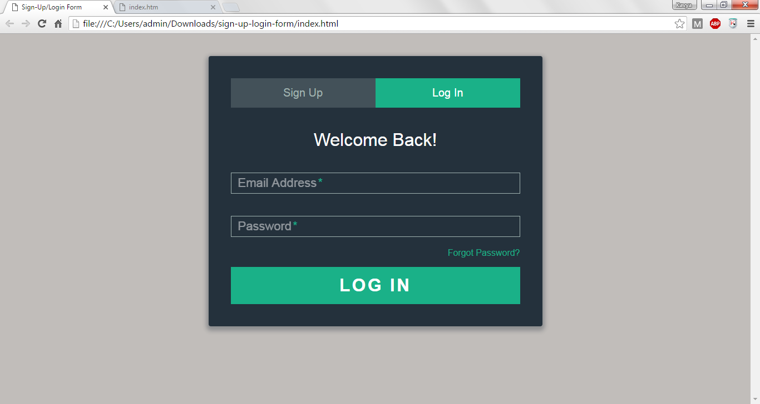

Figure 4.1 Login Page

This html is a login/sign up page. There are two tabs available here, the active tab is for sign up where user can enter the details and register. The next inactive tab is for log in here the user has to give his credentials to login to the control page.

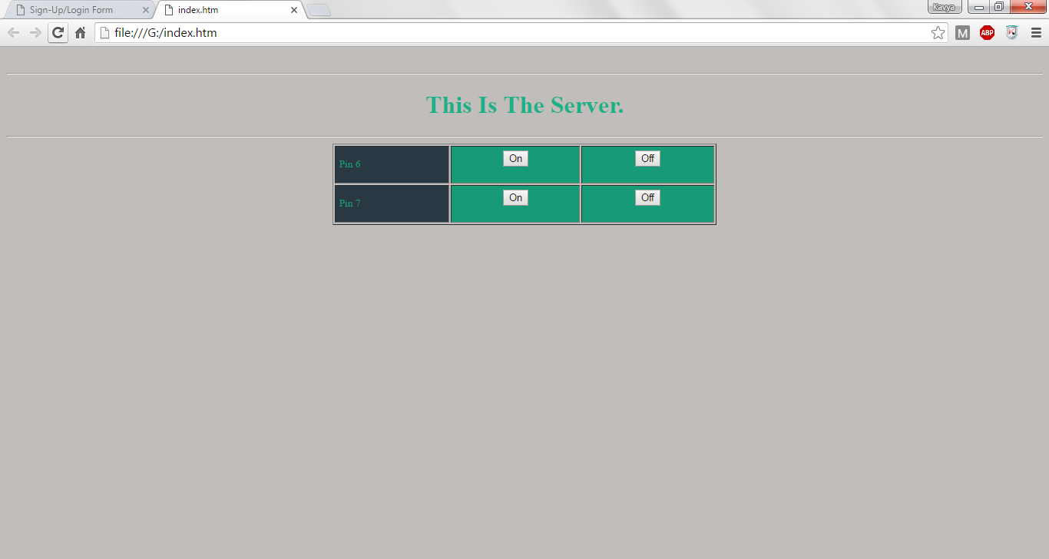

Figure no 4.2 Control page

This is the main control page of the system. This page may alter depending upon the user and his authority level. Here user can switch on or switch off the device by clicking respective ON/OFF button.

**CHAPTER 5**

**Conclusion**

The project was completed and is working as described. The system allows the user to control appliances and lights in their home from a smart phones and PC from anywhere in the world through an internet connection. The website has the primary control over the system; therefore if the internet connection is not active neither the Smartphone nor PC will be able to control the units in the home. This design works providing authenticated user the access to the smart home system and also guarantees to provide them the required privacy.

The project was tested to turn appliances on and off such as: light, fan etc. Home Automation is the residential extension of "building automation". It is automation of the home, housework or household activity. Home automation may include centralized control of lighting, heating, ventilation and air conditioning, appliances, and other systems, to provide improved convenience, comfort, energy efficiency and security.

A home automation system integrates electrical devices in a house with each other. The techniques employed in home automation include those in building automation as well as the control of domestic activities, such as TV, fan, electric tubes, refrigerator and washing machine. The system allows the user to control appliances and lights in their home from an android and PC from anywhere

Looking at the current situation we can build cross platform system that can be deployed on various platforms like Andriod, Windows. Limitation to control only several devices can be removed by extending automation of all other home appliances. Security cameras can be included, allowing the user to observe activity around a house or business. Security systems can include motion sensors that will detect any kind of unauthorized movement and notify the user. Scope of this project can be expanded to many areas by not restricting to only home.

**References**

[1]Kelly, S.D.T., Suryadevara, N.K. ; Mukhopadhyay, S.C. “Towards the Implementation of IoT for Environmental Condition Monitoring in Homes”, Sensors Journal, IEEE, Volume:13, pp- 3846 – 3853, May 2013.

[2]Sun Yi, Xu Chengwen, “The research of Bridge state monitoring system based on IOT technology”, IEEE International Conference on Advanced Management Science (ICAMS), Vol.3, pp. 87 – 90, July 2010.

[3] S.Pandikumar, R.S. Vetrivel, -“Internet of Things Based Architecture of Web and Smart Home Interface Using GSM”, International Journal of Innovative Research in Science, Engineering and Technology, Volume3, pp 1721-1727, March 2014.

[4]Mr. AbhishekVichare, Ms. ShilpaVerma ”Embedded Web Server for Home Appliances”, National Conference on Emerging Trends in Engineering & Technology, Volume5, pp 190-192, March 2012.

[5] Ming Wang, Guiqing Zhang, Chenghui Zhang, Jianbin Zhang, Chengdong Li. “An IoT-based appliance control system for smart homes”, Fourth International Conference on Intelligent Control and Information Processing (ICICIP), pp. 744 – 747, June 2013.

[6] Vinaysagar ,Kusuma S, ” Home Automation Using Internet of Things” International Research Journal of Engineering and Technology , Volume 2, pp 1965-1970, June 2015

[7] P Pravin Kumar, G Tirumala Vasu, India-“Home Automation & Security System Using Arduino Android ADK” International Journal of Emerging Trends in Engineering Research, Volume 3 , pp 190-194, 2015

[8] Chan, M., Campo, E., Esteve, D., Fourniols, J.Y., “Smart homes-current features and

future perspectives,” Maturitas, vol. 64, issue 2, pp. 90-97, 2009.

[9] ”Home Automation Info” homepage [Online]. Available:

<http://www.homeautomationinfo.com/Drupal/homeautomation_future>

[10] Internet of Things (IoT) -Based Home Automation Using GPRS Enabled Embedded Server for Remote Access Available: https://www.youtube.com/watch?v=hBF8u26oSMY

[11]www.instructables.com

[12]www.arduino.cc

**Publication**

Shreya Vhadadi, Bushra Shaikh, Niketa Rampally, Kavya Menda “Captious Nidus- Home Automation based on Iot”, International Journal of Computer Science, Information Technology, & Security  ,Volume 6, issue 2, pp-51-55,2016.